Changing Users Permissions in the Shared Folder
- Click More, then Permissions on any analysis, dashboard, etc.
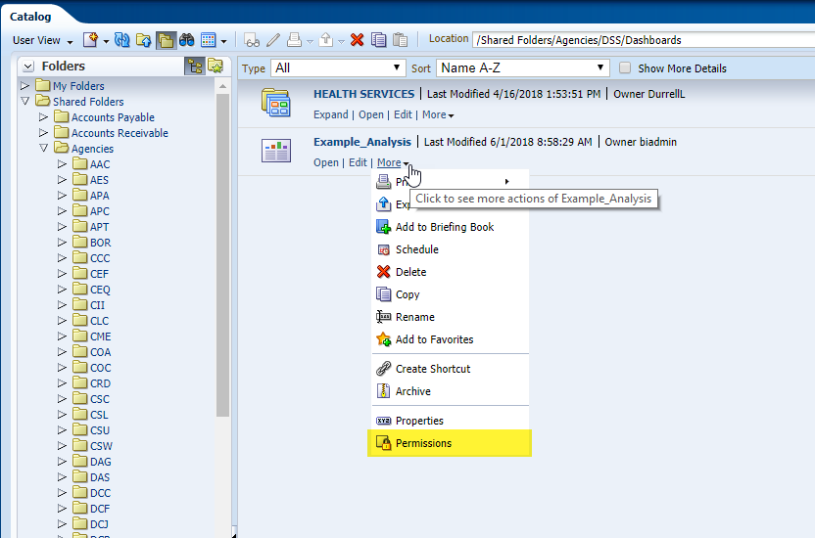

- Remove the non-super user role.
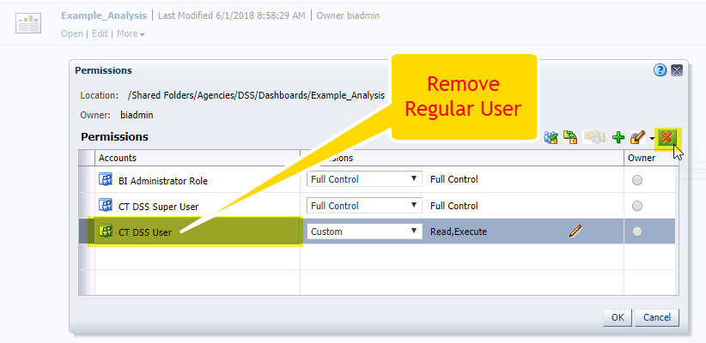

- Click add, choose Users from the List menu. 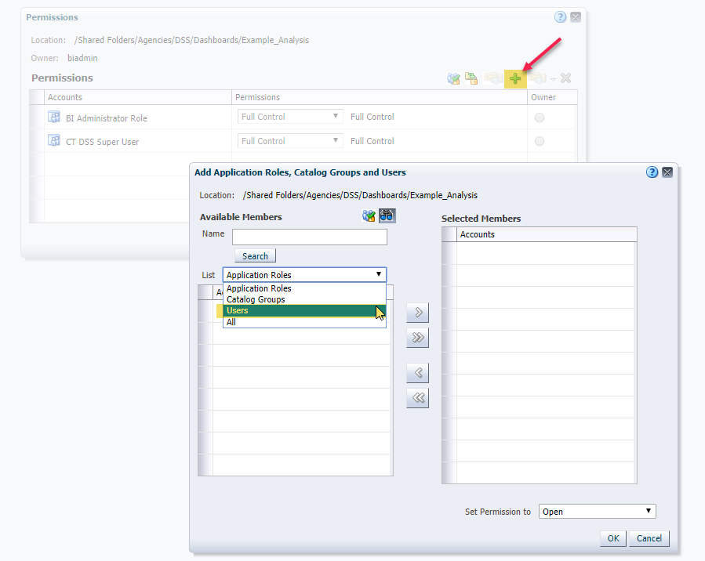

- Type the user ID, click search and add them with Open permission.
